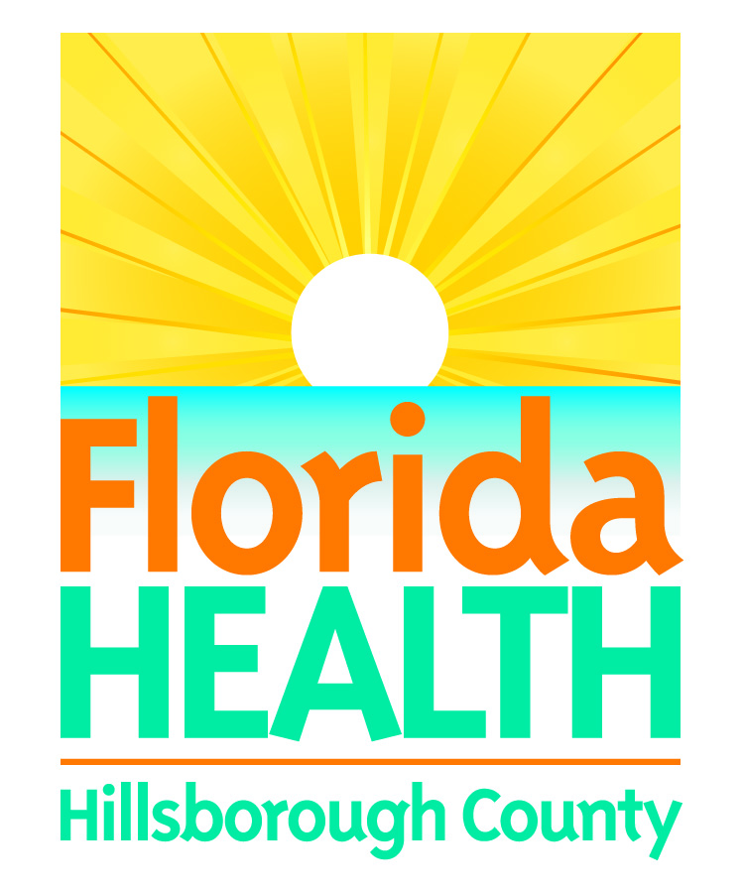
June 21, 2018
NEIGHBORHOOD CAT TESTS POSITIVE FOR RABIES, SEVERAL EXPOSED
Contact:
Kevin Watler
Public Information Officer
Florida Department of Health in Hillsborough County
kevin.watler@flhealth.gov
(813) 298-2024, cell
Tampa, Fla. – A neighborhood cat that lived around E. Bay Road in the Gibsonton area of Hillsborough County tested positive for rabies. Preliminary investigations revealed the grey tabby domestic shorthair cat exposed at least one adult, one child and one domestic dog. The cat also recently gave birth to several kittens. They will be tested for rabies. The Florida Department of Health in Hillsborough County (DOH-Hillsborough) is attempting to locate anyone who may have been exposed.

The two people with confirmed exposures have already begun rabies post exposure vaccines. The dog’s rabies vaccinations were up-to-date, but as a precaution, the dog received a booster for rabies and the owner has been asked to quarantine it for 45 days. This means the dog should not have contact with other animals or humans outside of the household during this period.

DOH-Hillsborough will be notifying all homes within a 500-foot radius of where the cat was found. Anyone who has been bitten, scratched, or exposed to the saliva of this cat is asked to report the exposure to DOH-Hillsborough.

This incident serves as a reminder that people should stay away from “neighborhood pets” or any wild animal. Some may be tempted to feed or help the animal, but it isn’t worth the risk.
DOH-Hillsborough strongly recommends avoiding contact with wildlife or any unknown animal. The only definitive way to determine if an animal has rabies is a lab examination. Last year, three animals exposed ten people.
In 2018, Hillsborough County has identified five rabid animals (three cats, one bat and one raccoon) that exposed 13 people and two domestic dogs to the disease. It’s clear that there are rabid animals living throughout the county and state.
An animal with rabies could infect other wild animals or domestic animals that have not been vaccinated against rabies. All domestic animals should be vaccinated against rabies and all wildlife contact should be avoided, particularly raccoons, bats, foxes, skunks, otters, bobcats, and coyotes. Rabies is a disease of the nervous system and is fatal to warm blooded animals and humans.
Residents and visitors are advised to take the following precautions:
- Keep rabies vaccinations up to date for all pets.
- If your pet is bitten by a wild animal, seek veterinary assistance for the animal immediately and contact the Hillsborough County Pet Resource Center at (813) 744-5660.
- Do not handle, feed, or unintentionally attract wild animals with open garbage cans or litter.
- Never adopt wild animals or bring them into your home.
- Teach children never to handle unfamiliar animals, wild or domestic, even if they appear friendly.
- Prevent bats from entering living quarters or occupied spaces in homes, churches, schools, and other similar areas, where they might come in contact with people and pets.
- Persons who have been bitten or scratched by wild or domestic animals should seek medical attention and report the injury to the Florida Department of Health in Hillsborough County at (813) 307-8059.

For further information on rabies, go to http://www.floridahealth.gov/diseases-and-conditions/rabies/index.html or call the Florida Department of Health in Hillsborough County at (813) 307-8000, or (813) 744-5660.

The Department works to protect, promote, and improve the health of all people in Florida through integrated state, county, and community efforts.

Follow us on Twitter at @DOHHillsborough and on Facebook. For more information about the Florida Department of Health please visit www.FloridaHealth.gov.

